Idaho, Oregon and Washington water quality agencies, and US EPA Region 10 are now leading the way in driving consistency among state water quality trading programs by engaging in development of a Joint Regional Agreement that will define a common framework under which trades should occur and a common set of procedures, standards and guidelines to govern trading. The state agencies, in collaboration with US EPA, will lead most of the components of this project, with Willamette Partnership providing support in coordination, facilitation and document management, and The Freshwater Trust advising and providing process support.



Figure 1. Oregon, Washington and Idaho water quality agencies and US EPA are direct participants in the Joint Regional Agreement process.

This framework will provide needed alignment and consistency among the states’ trading programs while maintaining essential flexibility to address state-specific parameters. The procedures and guidelines covered in the Joint Regional Agreement will ensure that trading programs have the quality, credibility and transparency necessary to be consistent with the Clean Water Act and ensure all trades achieve real water quality improvements.

Through a series of interagency workshops starting March 2013, state agencies, US EPA, Willamette Partnership, The Freshwater Trust and others will work

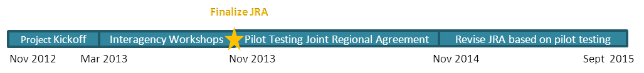

to craft these shared sprotocols and standard operating procedures. Beginning November 2013, states anticipate piloting the new framework and then revising it to incorporate lessons learned through the end of the project in September 2015. Throughout the process, project partners will engage stakeholders and coordinate with water quality trading programs currently under development in the Ohio River Valley, California, Colorado and other regions.

By creating consistency across states, the Joint Regional Agreement will increase the confidence of buyers and suppliers of water quality improvements and provide templates that other states can easily sign onto or adopt.

**WATER QUALITY TRADING**

Water quality trading is a cost-effective mechanism to help achieve local water quality improvements. Through water quality trading, sources with high costs of reducing pollution can purchase equal or greater pollution reductions from sources with lower costs.

The idea itself is not new, economists discussed trading in academic works as early as the 1960’s, and watersheds across the United States have used different forms of water quality trading in recent decades as a flexible tool for meeting water quality goals. Consistent and detailed policy around how water quality trading should work, however, has been slower to materialize.

In 2003, USEPA released its national policy framework for water quality trading. Since that time, only eight states have developed specific guidance for how it should occur. Three of those states – Idaho, Washington and Oregon– are located in the Pacific Northwest region and have considerable momentum behind their trading programs. In Oregon alone, over $20,000,000 has already been invested in restoration projects that generate water quality offsets, and another $13,000,000 in credit transactions are planned over the next few years. Over 200 landowners are or will be engaged in water quality trading programs by allowing conservation actions on their land in exchange for attractive incentive payments, and these actions will also provide numerous cobenefits to native fish and wildlife species.

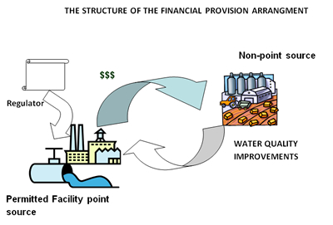

Figure 2. Water quality trading shifts compliance investment from gray to green infrastructure. Source: Bear River Watershed Information System.

**JOINT REGIONAL AGREEMENT PROCESS**

The project will use Willamette Partnership’s *Counting on the Environment* process to coordinate science and policy work across state lines and stakeholder interests. A working group of state water quality agency leads, US EPA Region 10, and The Freshwater Trust will review and process the recommendations made from technical groups focusing on the science and measurement of water quality improvements and the policy and protocol issues needed to support trading. Willamette Partnership will actively facilitate these groups through a series of in-person and telephone meetings over the course of the project period.

Willamette Partnership will also work with the agencies and The Freshwater Trust to consider input from producers, utilities, environmental groups, and others.

**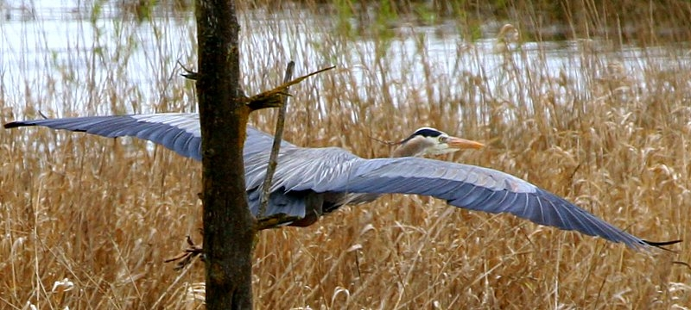**

Figure 3. Water quality trading can achieve regulatory compliance while providing cobenefits such as habitat for birds and other wildlife

The Joint Regional Agreement will follow a three-tiered structure that establishes consistent agency authorities and processes in Tiers One and Two, but allows individual state flexibility for the specific mechanics of trading in Tier Three:

* **Tier One:** **Agency Authorities for Trading**: Legal authorities for water quality trading including statutes, rules, case law and guidance.
* **Tier Two:** **Standard Operating Procedures**: The standards, processes and mechanics for trading programs (e.g. baseline and eligibility requirements, credit quantification tools, project quality guidelines, verification, monitoring and registration/reporting).
* **Tier Three: State Specific Addenda**: State-specific appendices that include unique baseline procedures, discounting and ratio factors, quality standards for conservation practices, etc.

Throughout the project, partners will actively participate in national conversations on the regional agency guidance and common tools needed to support water quality trading. The goal of this project is to build a state agency-approved water quality trading framework that is as “off the shelf” as possible, providing other states with an easily adoptable and customizable template for developing robust trading programs. The Joint Regional Agreement on Water Quality Trading also offers significant long-term benefits for land managers and producer groups, as a new revenue stream that encourages conservation practices on farms, forests and ranches.

**For more information about this project, contact:**

|  |  |
| --- | --- |
| Willametter Partnership ORIGINAL b-w.jpg | fwt_Logo.Horiz.CMYK.digital.inhouse.jpg |

Bobby Cochran, Willamette Partnership

*cochran@willamettepartnership.org*

Joe Furia, The Freshwater Trust

*furia@thefreshwatertrust.org*

DRAFT Project Brief:

Joint Regional Agreement on Water Quality Trading

**For more information, contact** [info@willamettepartnership.org](mailto:info@willamettepartnership.org)

503.681.5112