Discussion Guide, June 5-6th, 2013
This Discussion Guide is intended to provide definitions, context, analysis, and options for addressing various components of water quality trading programs. It poses questions that will be discussed at the interagency workshops. This document may reference other trading programs, examples, or documents, but is not intended to serve as a published report or white paper and thus will not be extensively cited. This document will be included in the workshop packet and posted online following each workshop.
6. Credit Characteristics
For any trading program, the essential characteristics of a credit need to be set, including agreed-upon standards that direct when a credit is created, when it expires, how it is treated from an accounting standpoint, and how many times it can be used for compliance or other purposes (e.g. stacking).

6.1/6.3 Credit life and renewal of credits 1
6.2. Accounting treatment of credits 3
6.4. Relation of water quality trading to other programs - stacking 4

6.1/6.3 Credit life and renewal of credits
A credit’s life spans the period between when a credit is created, or becomes “valid” and usable as an offset by a permittee, and when that credit is no longer valid. Credit life may differ from the temporal/contractual duration of the credit-generating BMPs. For example, the credit life of a nutrient credit will likely be one year or less (e.g. seasonal or monthly credit lives), even when a manure management BMP may go on for 20 or more years. Some credits (e.g. shade credits) are issued for a 20-year period and reported annually by the permittee.
I. Options and examples
When does a credit become valid?
Option A  A credit is valid once a BMP is verified as being installed according to approved practice standards.  Pros and Cons  This approach allows for immediate release of credits, reducing the burden on project developers to carry any up-front capital costs for credits. However, for those practices that take several years to reach their full potential, this kind of credit creation date may be inconsistent with the timing of the water quality benefits delivered by the BMP. | Option B  A credit is valid after a BMP is verified and quantified as meeting its full functional performance.  Pros and Cons  This approach ensures BMPs are providing their full pollution reduction before credits are released, but will likely increase the need for up-front capital and increase the burden on project developers to carry these up-front capital costs for a longer period of time.
Option C
Credits for BMPs that take time to mature can be released in phases based on achieving defined, milestone performance standards.

Pros and Cons
This approach is similar to wetland mitigation banking and strikes a balance between options A and B.
When does a credit expire?
Option A  So long as a BMP continues to function, and stewardship funds and land lease contracts are in place, a credit can be renewed for subsequent periods.  Pros and Cons  This approach links ongoing performance of BMPs with credits. This approach provides a mechanism for continued funding of already-installed BMPs. | Option B  After a certain number of permit cycles or years, BMPs are fully retired meaning that permittees would need to purchase new credit volumes from additional projects.  Pros and Cons  This approach continues to phase in more water quality improvements over time, thus helping to move the watershed closer to attainment of TMDL goals. This approach increases the cost of trading to permittees, as they will need to rebuild or repurchase all of the previously held credits.
Option C
After a certain number of permit cycles or years, the credits from previously installed BMPs may be renewed, but at a particular discount rate.

Pros and Cons?
This approach strikes a middle ground between options A and B in that it provides for more restoration, but also allows regulated entities to carry forward some balance of credits toward future compliance obligations, thus creating a long-term incentive for regulated entities to invest in and continue investing in maintenance of BMPs for water quality trading as a compliance solution.
For credits with a life that expires each year, when does a permittee need to show an appropriate balance of credits?
Option A  NPDES permittees must show they have the appropriate number of credits on their ledgers in accordance with the compliance schedule listed in their permit.  Pros and Cons  This approach is simple and provides a date certain for expiration of annual credits. | Option B  In addition to a specific date, trading programs may allow a “true-up” period where permittees can buy or sell additional credits to balance their ledgers.  Pros and Cons  This approach also provides a certain date, but provides some flexibility for permittees to adjust their ledger balances to ensure their needs for a given year are met.
II. Recommended default: A credit’s life should be defined by each trading program, with explicit creation and expiration dates. A credit becomes valid upon verification of a properly installed BMP or set of BMPs. For BMPs that take time to mature, that time lag in performance should be accounted for through the use of a trading ratio. Credits should be renewable, so long as BMPs continue to perform as verified and stewardship funds and contracts remain in place. Trading programs may define a true-up period just prior to a credit expiration date, so permittees can ensure they have the requisite amount of credits to meet compliance obligations.
III. Reasons to deviate from the default: Some states or watersheds may choose to retire BMPs after a certain length of time as a strategy for ensuring Load Allocations within a TMDL are met. Similarly, there may be instances where it is important not to award credit for slowly-maturing BMPs until they are providing water quality benefits (e.g. in a watershed with an immediate deadline to improve measured ambient water quality in 1-2 years, demanding a focus on management-based BMPs).

6.2. Accounting treatment of credits
Credits are a form of natural capital, but neither private nor government accounting standards are clear on how to define or value these kinds of assets. Trading programs need to consider how their rules and processes affect the accounting treatment of credits because it affects the ability of permitees to finance credit purchases.
If credits are seen as capital assets, it will likely be easier for permittees to fund credit purchases through traditional financing mechanisms like bonds and government loans. If credits are treated as non-depreciable, non-capital expenses for public purchasers, it may be more difficult to fund maintenance and monitoring components and credits with public financing money that is often oriented toward capital investments. The Governmental Accounting Standards Board (GASB), an independent, non-governmental organization that is a national leader in setting generally accepted accounting principles for state and local governments, defines a capital asset as “land, improvements to land, easements, buildings, building improvements, vehicles, machinery, equipment, works of art and historical treasures, infrastructure, and all other tangible or intangible assets that are used in operations and that have initial useful lives extending beyond a single reporting period.” Dams, power plants, water resources projects, and environmental remediation efforts intended to make a property usable again (often through decommissioning or decontamination) are considered capital assets. Capital assets should have clear ownership and are typically items that are useful for more than 1-2 years.
It is unclear whether a state water quality agency or an individual credit purchaser has the authority to classify credits as a capital asset. Further research is needed.

I. Options and Examples
Option A  Credits should be considered capital assets.  Pros and Cons?  If credits are defined in a way that is consistent with capital assets, there may be more flexibility for permitees to finance credit purchases through standard bonds, government loans, or other financing mechanisms. | Option B  Credits are considered non-capital assets.  Pros and Cons?  If credit costs are treated as operational expenses, then permitees may have more difficulty financing those costs. This treatment of credits is easily done under existing GASB guidance.
II. Recommended default: Option A - credits should be treated as capital assets. The value of a credit is its full life-cycle costs, including all direct and indirect costs for planning, purchase, operations and maintenance, and disposal
III. Reasons to deviate from the default: Are there scenarios in which credits should be considered with operational costs?

6.4. Relation of water quality trading to other programs - stacking
There is considerable debate as to the role of stacking—the ability of a water quality credit project to:
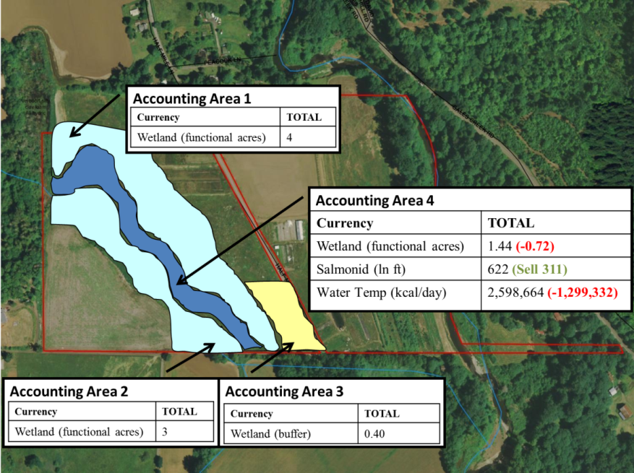
- Sell more than one kind of credit from the same action on the same area of land (stacking credits), or
Figure 0. Linking credits from the same action
- Use public conservation funds to help fund actions that generate credits (stacking payments)
Several academic papers provide detailed definitions of stacking.
Arguments in favor of stacking include:
- If an action generates multiple actions, then a project developer should be able to sell multiple benefits—increasing the revenue potential for conservation and restoration projects, so they are more competitive with other land use choices such as corn or development.”
Arguments against stacking include:
- Stacking is more likely to result in net losses in conservation, and creates challenges for consistent accounting.
The options below draw from the positions taken by different programs in terms of stacking of credits (generation of multiple credits for the same action) and stacking of payments (receiving multiple payments for the same action).
I. Options and examples—Stacking credits
Option A  Stacking is not allowed. Project developers can generate multiple credits for the same action. These credits are linked and sold proportionally. As a % of one credit type is sold, a corresponding % of all other credit types from that area are deducted from the ledger.  Who does it this way?  WP and Electric Power Research Institute (EPRI) have both adopted this approach to credit stacking. This approach still provides project developer choices, but precludes the perception of double dipping.  The only exception is that if an impact affects multiple resources (e.g. discharging nitrogen and phosphorous), a BMP that reduces both pollutants may be creditable for both impacts. | Option B  Credit stacking is allowed. Project developers can generate multiple credits for the same action and all credits can be sold individually.  Who does it this way?  North Carolina used to allow stacking (it no longer does). Originally, North Carolina wanted to recognize multiple benefits of complex restoration, but the backlash from a sale of stacked credits changed their policy.
Option C
Credit stacking is not allowed. Multiple credits cannot be generated for the same action.

Who does it this way?
Climate Action Reserve currently prohibits stacking of carbon and water quality credits. They may revise this policy, but didn’t see the need to allow it at this time.

II. Options and examples—Stacking payments
Option A
Stacking payments is not allowed. Public conservation dollars can fund a portion of a credit project (i.e. baseline), but the project developer can only sell the remaining portion not funded by those dollars.

Who does it this way?
This approach is derived from joint interagency guidance developed in Oregon. Willamette Partnership, Electric Power Research Institute, and Climate Action Reserve have all adopted this approach to credit stacking. It still provides project developer choices, but prevents any perception of double dipping.
Option B  Payment stacking is allowed  Who does it this way?  USDA explicitly states that BMPs that its funds, and any associated credits, belong to producers. | Option C  Payment stacking is not allowed  Who does it this way?  Some programs prohibit any cost-shared BMP to produce credits. This approach would trigger changes in several programs where USDA cost share is used to fund a small portion of credit-generating activities
III. Recommended default: Option A is recommended for both credit and payment stacking. A project developer may create more than one credit for an action on the same area, and the credit generated by the same action in the same area are linked and sold proportionally (i.e., as a % of credits of one type are sold, the same % of credits from all other types must be deducted from the ledger for that area at the same time (Figure 1)). The project developer may use a proportion of public conservation dollars to fund credit-generating actions. However, only the % of credits not funded by public conservation dollars can be sold.
For this scenario to be viable, all credits must be validated, calculated, and verified at the same time. They must be subject to the same performance standards, credit release schedules, and stewardship requirements. Where performance standards, credit release schedules, or stewardship requirements differ for the actions or credits in question, the most conservative standard applies (e.g. If one credit is released on installation and the other is phased, the slower, phased release schedule applies to both).

III. Reasons to deviate from the default: Sometimes, the credit buyers may be offsetting an impact affects multiple resources. In this case, consider allowing the buyer to purchase credits that match the fingerprint of those multiple resources (e.g. an impact to temperature and wetlands can be offset by a project benefiting both resources).

Governmental Accounting Standards Board (GASB) Statement No. 34, Basic Financial Statements—and Management’s Discussion and Analysis—for State and Local Governments, ¶ 19.
See, e.g., Cooley and Olander, Nicholas Institute Working Paper, Tacking Ecosystem Services Payments: Risks and Solutions (2011), available at http://nicholasinstitute.duke.edu/sites/default/files/publications/stacking-ecosystem-services-payments-paper.pdf; Fox, Gardner, and Maki, Stacking Opportunities and Risks in Environmental Credit Markets, 41 Environmental Law Reporter 10122 (2011), available at http://wqt.epri.com/pdf/credit-stacking-environmental-opportunities-and-risks.pdf.
U.S. Fish and Wildlife Service, National Marine Fisheries Service, U.S. Environmental Protection Agency, U.S. Army Corps of Engineers, Oregon Department of State Lands, Oregon Watershed Enhancement Board, Oregon Department of Fish and Wildlife, Oregon Interagency Recommendations: Public Funds to Restore, Enhance, and Protect Wetland and At-Risk, Threatened and Endangered Species Habitats: Appropriate Uses of These Funds in Species and Wetland Mitigation Projects (2008), available at http://www.fws.gov/oregonfwo/LandAndWater/Documents/PublicFunding-final.pdf
Greenhalgh, Selman, and Taylor, Conservation Best Management Practices, Cost-Share, and Water Quality Trading Programs, WRI Policy Note - Environmental Markets: Water Quality Trading No. 2. World Resources Institute (2006), available at http://pdf.wri.org/pn_envmkts_conservation_cost_share.pdf.

