Idaho, Oregon and Washington water quality agencies, and US EPA Region 10 are working together to reach a joint regional agreement on what they consider the best practices to follow when engaging in water quality trading (“JRA”). The state agencies, in collaboration with US EPA, will lead most of the components of this project. Willamette Partnership and The Freshwater Trust will be supporting the discussions.



Figure 1. The participants in this process include Oregon, Washington and Idaho water quality agencies and US EPA .

The best practices defined through this process will include those practices that apply in all three states and will also describe those practices that are specific to each state. The goal is to help ensure that trading programs have the quality, credibility and transparency necessary to be consistent with the Clean Water Act and ensure all trades achieve water quality improvements.

Through a series of interagency workshops starting March 2013, state agencies, US EPA, Willamette Partnership, The Freshwater Trust and others will work to craft these shared practices for trading.

Beginning November 2013, states anticipate testing some of these ideas from a draft framework and then revising it to incorporate lessons learned through the end of the project in September 2015.

Throughout the process, project partners will engage stakeholders and coordinate with water quality trading programs in other regions.

By defining best practices for their states, this project will help to create consistency across states, increasing the confidence of participants and observers that trades produce their intended water quality benefits.

**WATER QUALITY TRADING**

Water quality trading is a mechanism to help achieve local water quality improvements.

The idea itself is not new. Watersheds across the United States have used different forms of water quality trading in recent decades as a flexible tool for meeting water quality goals. However, consistent and detailed policy around how water quality trading should work has been slower to materialize.

In 2003, USEPA released its national policy framework for water quality trading. Since that time, only eight states have developed specific guidance for how it should occur. Three of those states – Idaho, Washington and Oregon– are located in the Pacific Northwest region and have generated considerable interest in their trading programs.

In Oregon alone, over $20,000,000 has already been invested in restoration projects that generate water quality offsets, and another $13,000,000 in credit transactions are planned over the next few years. Over 200 landowners are or will be engaged in water quality trading programs by allowing conservation actions on their land, and these actions will also provide numerous co-benefits to native fish and wildlife species.

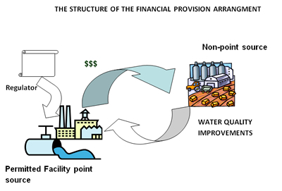

Figure 2. Water quality trading provides flexibility in compliance options for both gray to green infrastructure. Source: Bear River Watershed Information System.

**Project Specifics** The project will rely on a working group of state water quality agency leads and US EPA Region 10 to identify the places where states are similar and different and some recommendations for water quality trading best practices. That group will be facilitated by Willamette Partnership. Information from those discussions will be put up on the Willamette Partnership’s website.

Willamette Partnership will also work with the agencies to consider input from producers, utilities, environmental groups, and others.

The project will proceed in three tiers:

* **Tier One:** **Legal Framework for Trading**: The framework in which water quality trading can and will occur.
* **Tier Two:** **Standard Operating Procedures**: Identification of the best practices for building and running trading programs (e.g. baseline and eligibility criteria, credit quantification tools, project quality guidelines, verification, monitoring and registration/reporting).
* **Tier Three: State Specific Addenda**: Identification of state-specific nuances that include unique baseline procedures, discounting and ratio factors, quality standards for conservation practices, etc.

The project is supported by a grant from USDA’s Natural Resources Conservation Service CIG program awarded November 2012. An initial set of best practices should be complete by November 2013 to test in different states, and then they will be revised in late 2014 to complete the project by 2015.

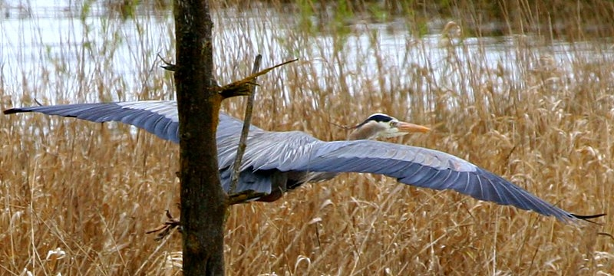

Figure 3. Water quality trading can achieve regulatory compliance while providing co-benefits such as habitat for birds and other wildlife

Throughout the project, partners will actively participate in national conversations on the regional agency guidance and common tools needed to support water quality trading. Our hope for this project is to articulate shared best practices for trading in the Northwest in a way that shapes trading in the region, but also provides tools that other states can use as they consider their own trading programs. In the end, participants in this process want to ensure that when trading programs are used for compliance, they create verifiable improvements in water quality.

**For more information about this project, contact:**

|  |  |
| --- | --- |
| Willametter Partnership ORIGINAL b-w.jpg | fwt_Logo.Horiz.CMYK.digital.inhouse.jpg |

Bobby Cochran, Willamette Partnership

*cochran@willamettepartnership.org*

Joe Furia, The Freshwater Trust

*furia@thefreshwatertrust.org*

Claire Schary, USEPA Region 10

*Schary.claire@epa.gov*

Marti Bridges, Idaho DEQ

*Marti.bridges@deq.idaho.gov*

Ranei Nomura, Oregon DEQ

*Nomura.ranei@deq.state.or.us*

Helen Bresler, Washington Dept. of Ecology

*Hbre461@ecy.wa.gov*

DRAFT Best Practices for Water Quality Trading

Joint Regional Agreement: Project Brief April 18, 2013

**For more information, contact** [info@willamettepartnership.org](mailto:info@willamettepartnership.org)

503.681.5112