**PROJECT GOAL**

The goal of this project is to help ensure that water quality trading programs have the quality, credibility, and transparency necessary to be consistent with the Clean Water Act and make certain all trades achieve water quality improvements.

To accomplish this goal, the project will define best practices that apply in all three states and will also describe those practices that are specific to each state. This process may help to create consistency across states, increasing the confidence of participants and observers that trades produce their intended water quality benefits and comply with applicable Clean Water Act regulations.

**STATUS OF WATER QUALITY TRADING**

In 2003, EPA released its national policy framework for water quality trading. Since that time, only ten states have developed specific guidance for how it should occur. Three of those states – Idaho, Washington and Oregon – are located in the Pacific Northwest region and have generated considerable interest in their trading programs.

In Oregon alone, over $20,000,000 has already been committed to restoration projects that generate water quality credits, and another $13,000,000 in credit transactions are planned over the next few years. These credits represent verified shade restoration projects that will lead to measurable water quality improvements. Over 200 landowners are or will be engaged in water quality trading programs by allowing restoration actions on their land, and these actions will also provide numerous co-benefits to native fish and wildlife species.

**PROJECT TIMELINE**

Through a series of interagency workshops starting March 2013, state agencies, US EPA Region 10, Willamette Partnership, The Freshwater Trust and others will work to craft these potential shared practices for trading in the Pacific Northwest. Beginning November 2013, states anticipate testing some of the ideas from the draft framework by implementing pilot projects in selected watersheds. The framework will then be revised to incorporate lessons learned through the end of the project in September 2015. The states may choose to update their own trading program’s rules or guidance to incorporate the best practices, following their state’s procedures for public participation and input.

**SPECIFIC PROJECT TASKS**

The project will proceed in three tiers:

* **Tier One:** **Legal Framework for Trading**: The framework in which water quality trading can and will occur in the Pacific Northwest.
* **Tier Two:** **Standard Operating Procedures**: Identification of the best practices for building and running trading programs (e.g. baseline and eligibility criteria, credit quantification tools, project quality guidelines, verification, monitoring and registration/reporting).
* **Tier Three: State Specific Addenda**: Identification of state-specific nuances that include unique baseline procedures, discounting and ratio factors, quality standards for conservation practices, etc.

**HOW IS THIS PROJECT FUNDED?**

The project is supported by a $1.5 million grant from USDA’s Natural Resources Conservation Service CIG program awarded November 2012 to the Willamette Partnership.

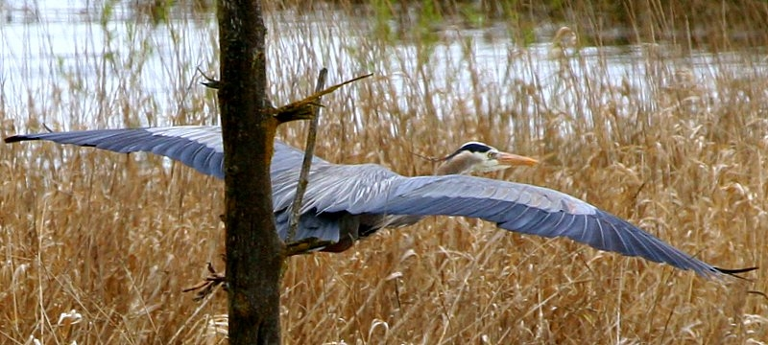

Figure 2. Water quality trading can achieve regulatory compliance while providing co-benefits such as habitat for birds and other wildlife

**FOR MORE INFORMATION**

Information is available on the Willamette Partnership’s website at <http://willamettepartnership.org/> and from the following contact list:

|  |  |
| --- | --- |
| Willametter Partnership ORIGINAL b-w.jpg | fwt_Logo.Horiz.CMYK.digital.inhouse.jpg |

Bobby Cochran, Willamette Partnership

*cochran@willamettepartnership.org*

*(503) 946-8350*

Joe Furia, The Freshwater Trust

*furia@thefreshwatertrust.org*

*(503) 222-9091*

Claire Schary, USEPA Region 10

*Schary.claire@epa.gov*

*(206) 553-8514*

Marti Bridges, Idaho DEQ

*Marti.bridges@deq.idaho.gov*

*(208) 373-0382*

Ranei Nomura, Oregon DEQ

*Nomura.ranei@deq.state.or.us*

*(541) 686-7799*

Helen Bresler, Washington Dept. of Ecology

*Hbre461@ecy.wa.gov*

*(360) 407-6180*

**OVERVIEW**

Idaho, Oregon, and Washington water quality agencies, and U.S. EPA Region 10 are working together on a potential joint regional agreement defining what they consider the best practices to follow when implementing water quality trading. Throughout this process, project partners will engage stakeholders and coordinate with water quality trading programs across the country. After identifying regional best practices for water quality trading, states may then choose to update their trading programs as needed and according to their own program revision processes, including opportunities for public input.

The Willamette Partnership and The Freshwater Trust, non-profit groups interested in increasing the pace and effectiveness of restoration activities throughout the Pacific Northwest, will be facilitating these discussions.

**WHAT IS WATER QUALITY TRADING?**

Water quality trading is a mechanism to help achieve local water quality improvements. Trading allows sources with very high costs of reducing pollution to negotiate equal or greater pollution reductions from sources with lower cost.

The idea itself is not new. Watersheds across the United States have used different forms of water quality trading in recent decades as a tool for meeting water quality goals.

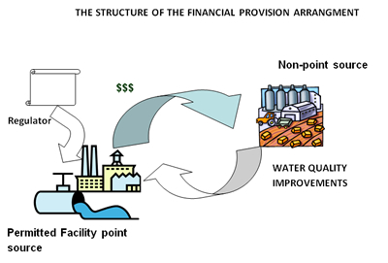

Figure 1. Water quality trading provides flexibility in compliance options for both gray to green infrastructure. Source: Bear River Watershed Information System.

Best Practices for Water Quality Trading

Joint Regional Agreement: Fact Sheet June 17, 2013

**For more information, contact** [info@willamettepartnership.org](mailto:info@willamettepartnership.org)

503.681.5112